Posted 09/21/2016 at 2:55 pm by JAV

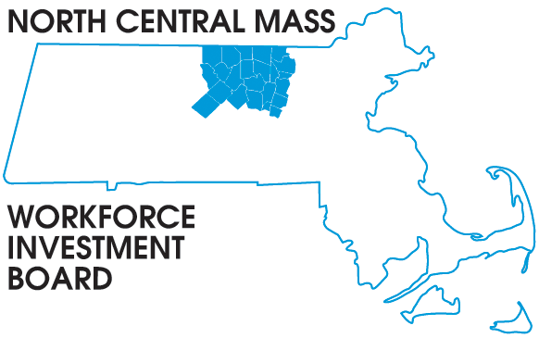
1355 Central Street Leominster, MA 01453 Phone: (978) 534 1023 Fax: (978) 534 1807

BOARD OF DIRECTORS MEETING

Tuesday, September 27, 2016

Leominster Credit Union
20 Adams Street Leominster, MA
8:00 a.m. – 9:30 a.m.

AGENDA

Welcome Everyone

Approve Minutes of the June 14, 2016 meeting (Vote required)

Approve the August 23, 2016 Executive Committee report (Vote required)

Finance: Mike Noble

Executive: Barbara Mahoney

Jeff Roberge: MRC 2016 Employer Conference October 12th

Jackie Belrose: Tech Hire Grant

Executive Directors report:
Jobs and Workforce Summit October 26, Devens Commons
WIOA updates: (Interim MOU signed, Strategic Plan complete, RFP & Bidders Conference complete, Proposals due October 28th, Proposal review committee meets November 15th, Board Certification extended until June, 2017)
HI-B, NEG and Disability Grant updates

Other Business

